INTERSHIP PROJECT DOCUMENTATION
NAME: MINU RANI SAHU, ANANYA, RITHIKA
DATE: 28/02/2026

1.Project Overview
The Recipe Finder Application is a Python-based program developed to help users discover recipes using the ingredients available to them. The system takes user input in the form of ingredients and matches them with recipes stored in a dataset.
The application simplifies meal planning and reduces the time spent searching for suitable recipes manually.

2. Introduction
Cooking decisions can often be challenging when ingredients are limited. Many people search online for recipes but struggle to find options that match what they already have at home.
The Recipe Finder application addresses this problem by providing an easyto-use system that suggests recipes based on available ingredients. The project demonstrates the practical application of Python programming concepts such as condition checking, loops, functions, and data handling.

3. Problem Statement
There is a need for a simple tool that helps users identify recipes they can prepare using the ingredients already available in their kitchen.
Manual searching is time-consuming and ine icient. Therefore, an automated recipe recommendation system is required.

4. Objectives
The main objectives of this project are:
- To design and develop a recipe recommendation system
- To allow users to search recipes using ingredients
- To match and filter recipes efficiently
- To display recipe information clearly
- To improve programming and logical thinking skills

5. Technologies Used
- Programming Language: Python
- Development Environment: Visual Studio Code
Libraries Used:
- Matplotlib (for data visualization, if implemented)
- Data Storage: JSON / CSV file (for recipe dataset)

6. System Architecture
The system consists of:
- A main Python file that runs the application
- A dataset containing recipes and ingredients
- Logic to compare user input with stored recipes
- Optional visualization component
The program runs in a command-line interface where the user interacts through text input.

7. Methodology
The application works through the following steps:
- The user runs the program.
- The system prompts the user to enter ingredients.
- The input is processed and compared with the recipe dataset.
- The program searches for matching recipes.
- If matching recipes are found, they are displayed.
- If no match is found, the system displays an appropriate message.
- Nutritional values may be displayed in graphical format (if implemented).
This structured process ensures accurate and e icient recipe recommendations.

- Implementation Details
The recipe data is stored in structured format (JSON/CSV).
- Ingredient matching is performed using conditional statements and loops.
- Functions are used to organize code for better readability and reusability.
- Error handling ensures smooth user interaction.

9. Results
The Recipe Finder Application successfully:
- Accepts user input
- Filters recipes based on ingredients
- Displays matching recipes
- Provides clear output to the user
- Generates charts (if visualization feature is included)

Week 1: Output week 2: Output
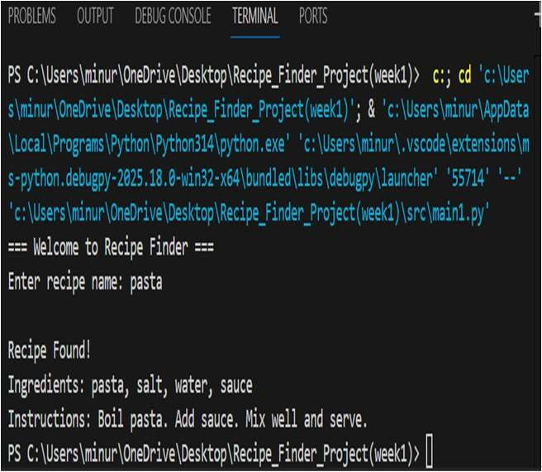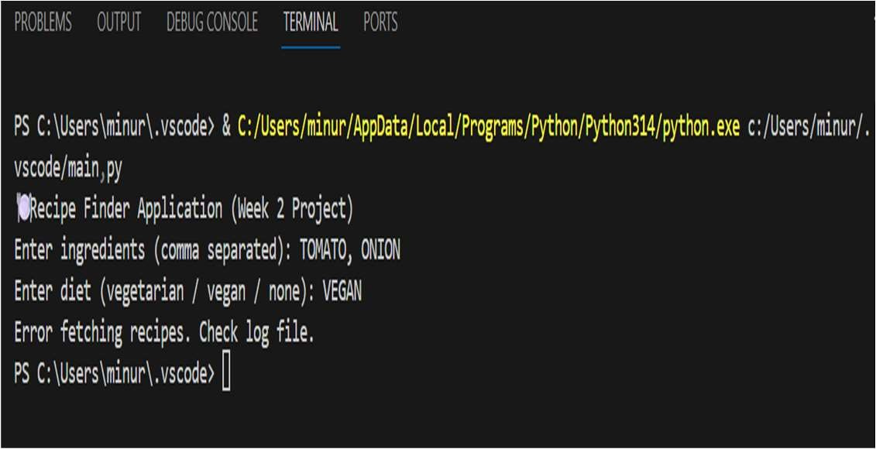

Week3: Output
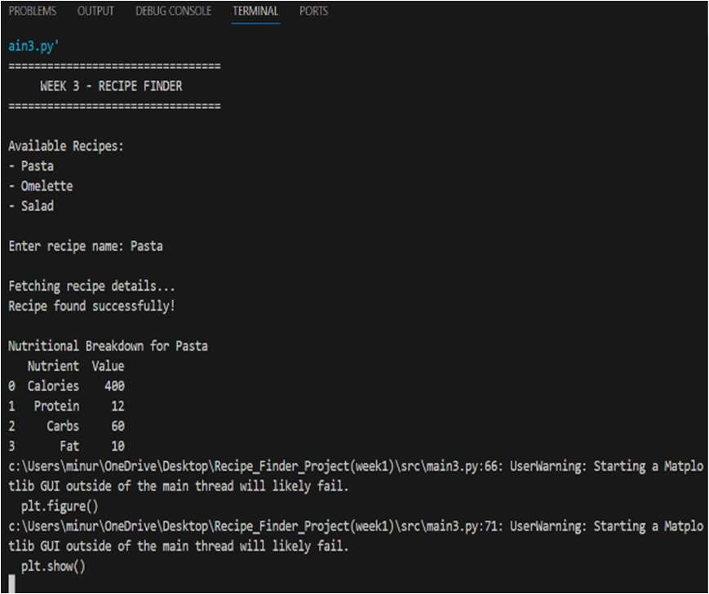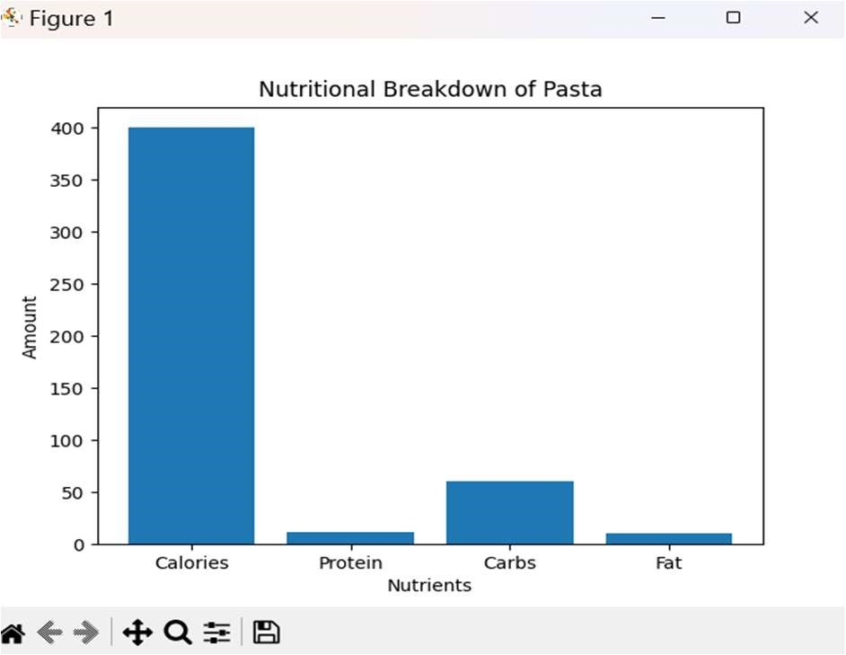

Week 4: Output Figure 1: Recipe Finder GUI Window

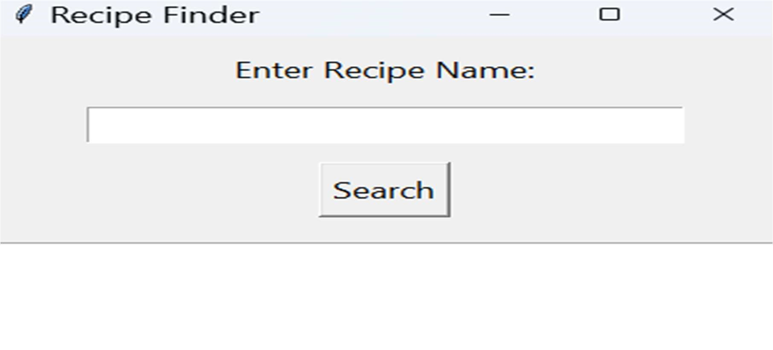

Figure 2: Output For Valid Recipe Search

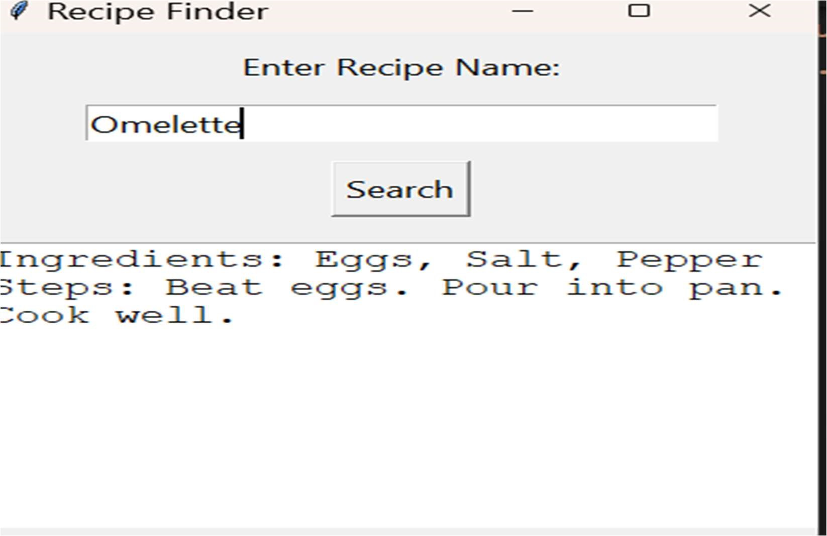

Figure 3: Error Displayed for Invalid Recipe

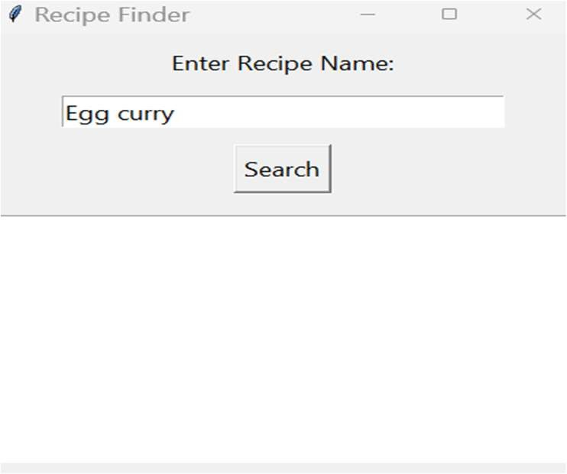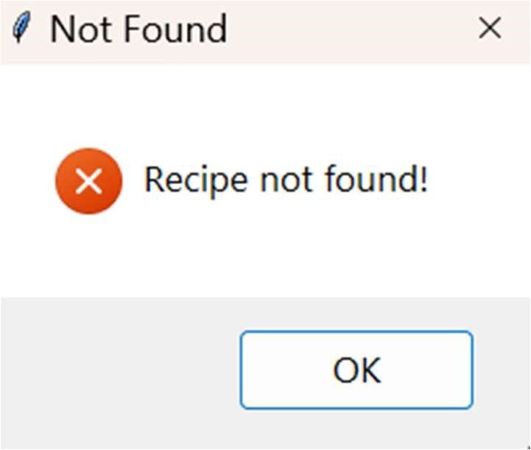

Figure 4: Warning Displayed When Input Is Empty

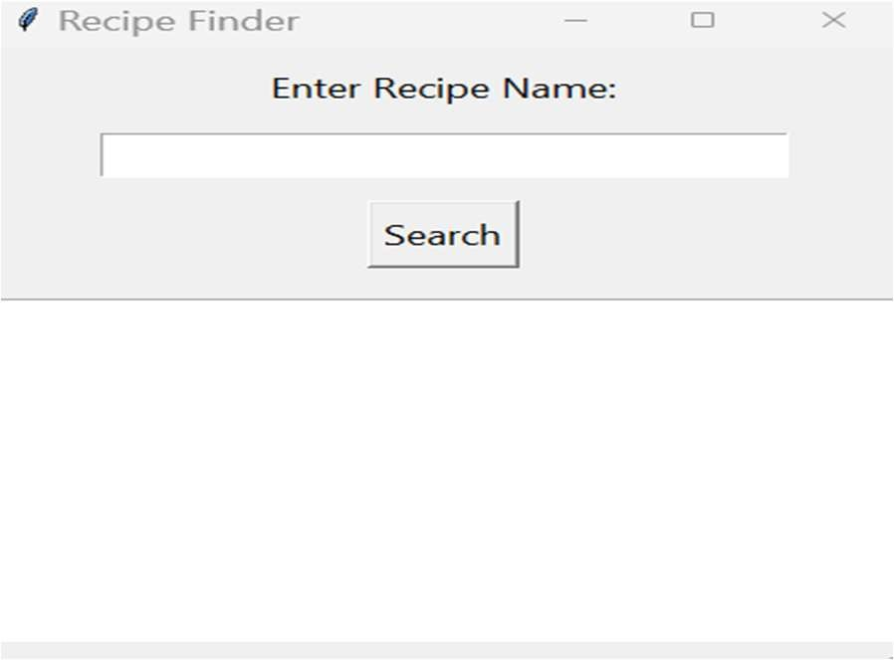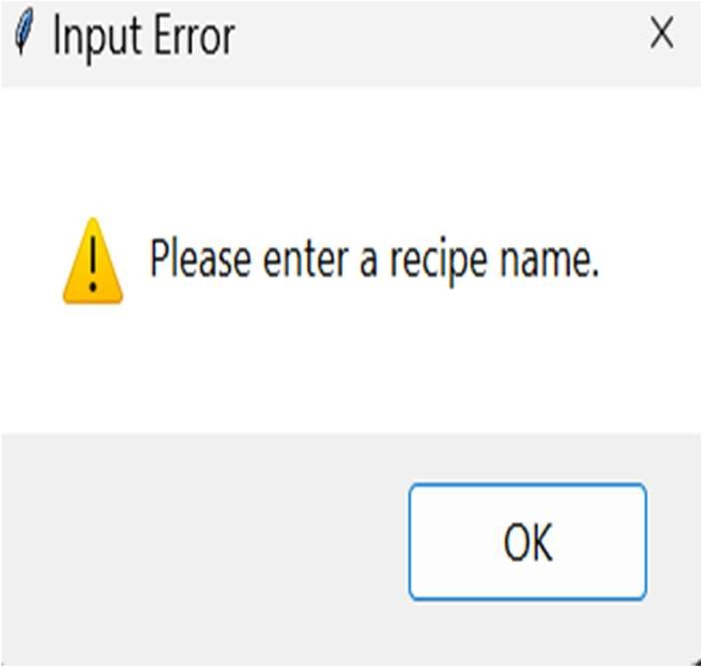

10. Challenges Faced
- Handling incorrect user input
- Matching ingredients accurately
- Debugging runtime errors
- Managing dataset structure

11. Conclusion
The Recipe Finder Application successfully demonstrates how Python can be used to develop a practical, real-world solution. The system makes cooking easier by suggesting recipes based on available ingredients.
This project enhanced my understanding of Python programming, logical thinking, and data processing techniques.

12. Future Enhancements
- Adding a graphical user interface (GUI)
- Deploying as a web application
- Integrating an online recipe database
- Adding filters such as cuisine type, calories, or preparation time

